|  |  |
| --- | --- |
| **Gerb-BMSTU_01** | **Министерство науки и высшего образования Российской Федерации**  Калужский филиал  федерального государственного бюджетного  образовательного учреждения высшего образования  ***«Московский государственный технический университет имени Н.Э. Баумана (национальный исследовательский университет)»***  ***(КФ МГТУ им. Н.Э. Баумана)*** |

**ФАКУЛЬТЕТ** \_***ИУК «Информатика и управление»*\_\_**\_\_\_\_\_\_\_\_\_\_\_\_

**КАФЕДРА** \_\_***ИУК4 «Программное обеспечение ЭВМ, информационные технологии»***

**ЛАБОРАТОРНАЯ РАБОТА №3**

**«Особенности среды Android Studio для разработки приложений Android. Простое Android приложение»**

**ДИСЦИПЛИНА: «Разработка мобильного ПО»**

|  |  |  |
| --- | --- | --- |
| Выполнил: студент гр. ИУК4-52Б | | \_\_\_\_\_\_\_\_\_\_\_\_\_\_\_\_\_ (\_\_\_\_\_\_Губин Е.В.\_\_\_\_\_)  (Подпись) (Ф.И.О.) |
| Проверил: | | \_\_\_\_\_\_\_\_\_\_\_\_\_\_\_\_\_ (\_\_\_\_\_Прудяк П.Н.\_\_\_\_\_)  (Подпись) (Ф.И.О.) |
| Дата сдачи (защиты):  Результаты сдачи (защиты): | | |
|  | - Балльная оценка:  - Оценка: | |
| Калуга, 2024 г. | | |

**Цель:** приобретение практических навыков разработки приложений с несколькими Activity и Intent-объектами.

**Задачи:**

1. Изучить механизм создания многоэкранных приложений на платформе Android

2. Научиться разрабатывать приложения с использованием явного и неявного вызова классов

3. Понять особенности реализации Android-приложений с использованием Intent-объектов

**Формулировка задания:**

**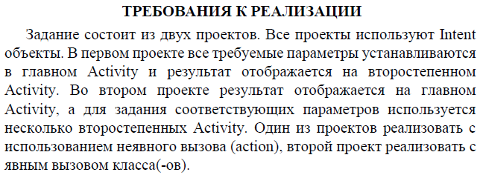**

**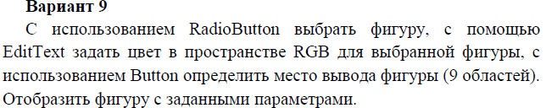**

**Проект 1**

**Листинг программы:**

**СircleView.kt (рисует круг с использованием холста canvas):**

package com.example.lw\_3\_1

import android.content.Context

import android.graphics.Canvas

import android.graphics.Color

import android.graphics.Paint

import android.view.View

class CircleView(context: Context?): View(context) {

private val paint: Paint = Paint()

private var r: Int = 0

private var g: Int = 0

private var b: Int = 0

private var positions: ArrayList<Int>? = ArrayList()

private var radius: Float = 100f

fun init(r: Int, g: Int, b: Int, positions: ArrayList<Int>?) {

this.positions = positions

this.r = r

this.g = g

this.b = b

this.paint.apply {

style = Paint.Style.FILL

color = Color.rgb(r, g, b)

}

}

override fun onDraw(canvas: Canvas) {

super.onDraw(canvas)

this.positions?.let { postList ->

val metrics = context.resources.displayMetrics

val horizontalPadding: Float = (metrics.widthPixels - this.radius \* 6) / 4

val verticalPadding: Float = (metrics.heightPixels - this.radius \* 6) / 4

var cx = 0F

var cy = 0F

var row = 0

var col = 0

for (post in postList) {

row = post / 3

col = post % 3

cx = (1 + col).toFloat() \* horizontalPadding + this.radius \* ((2 \* col).toFloat() + 1)

cy = (1 + row).toFloat() \* verticalPadding + this.radius \* ((2 \* row).toFloat() + 1)

canvas.drawCircle(cx, cy, this.radius, this.paint)

}

}

}

}

**MainActivity.kt (описывает главную Activity с выбором типа и цвета фигуры):**

package com.example.lw\_3\_1

import android.content.Intent

import android.os.Bundle

import android.widget.Button

import android.widget.EditText

import android.widget.RadioButton

import android.widget.RadioGroup

import android.widget.Toast

import androidx.activity.enableEdgeToEdge

import androidx.appcompat.app.AppCompatActivity

import androidx.core.view.ViewCompat

import androidx.core.view.WindowInsetsCompat

class MainActivity : AppCompatActivity() {

private lateinit var radioGroup: RadioGroup

private lateinit var button: Button

private lateinit var editText: EditText

private lateinit var selectedFigure: String

private lateinit var rgb: Array<Int>

private lateinit var rectangleRadio: RadioButton

private lateinit var circleRadio: RadioButton

override fun onCreate(savedInstanceState: Bundle?) {

super.onCreate(savedInstanceState)

enableEdgeToEdge()

setContentView(R.layout.activity\_main)

this.circleRadio = findViewById(R.id.circleRadioButton)

this.rectangleRadio = findViewById(R.id.rectangleRadioButton)

this.radioGroup = findViewById(R.id.radioGroup)

this.radioGroup.setOnCheckedChangeListener(

RadioGroup.OnCheckedChangeListener{ group, checkedId ->

val radio: RadioButton = findViewById(checkedId)

val text: String = radio.text.toString()

this.selectedFigure = text

}

)

this.button = findViewById(R.id.selectionButton)

this.button.setOnClickListener {

if (!this.rectangleRadio.isChecked && !this.circleRadio.isChecked) {

Toast.makeText(this, "Select a figure!!!", Toast.LENGTH\_LONG).show()

}

else {

this.editText = findViewById(R.id.editText)

val pattern = Regex("^[0-9]{1,3} [0-9]{1,3} [0-9]{1,3}$")

if (pattern.containsMatchIn(editText.text)) {

val text: String = editText.text.toString()

this.rgb = (text.split(" ").map { it.toInt() }).toTypedArray()

if (rgb[0] <= 255 && rgb[1] <= 255 && rgb[2] <= 255) {

val intent = Intent()

intent.action = Intent.ACTION\_ASSIST

intent.addCategory(Intent.CATEGORY\_DEFAULT)

intent.putExtra("selectedFigure", this.selectedFigure)

intent.putExtra("r", this.rgb[0])

intent.putExtra("g", this.rgb[1])

intent.putExtra("b", this.rgb[2])

startActivity(intent)

}

else {

Toast.makeText(this, "Select a figure!!!", Toast.LENGTH\_LONG).show()

}

}

else {

Toast.makeText(this, "Incorrect format", Toast.LENGTH\_LONG).show()

}

}

}

ViewCompat.setOnApplyWindowInsetsListener(findViewById(R.id.main)) { v, insets ->

val systemBars = insets.getInsets(WindowInsetsCompat.Type.systemBars())

v.setPadding(systemBars.left, systemBars.top, systemBars.right, systemBars.bottom)

insets

}

}

}

**MainActivity2.kt (описывает Activity с выбором позиций отрисовки):**

package com.example.lw\_3\_1

import android.content.Intent

import android.os.Bundle

import android.widget.Button

import androidx.activity.enableEdgeToEdge

import androidx.appcompat.app.AppCompatActivity

import androidx.core.view.ViewCompat

import androidx.core.view.WindowInsetsCompat

class MainActivity2 : AppCompatActivity() {

private lateinit var button1: Button

private lateinit var button2: Button

private lateinit var button3: Button

private lateinit var button4: Button

private lateinit var button5: Button

private lateinit var button6: Button

private lateinit var button7: Button

private lateinit var button8: Button

private lateinit var button9: Button

private lateinit var drawButton: Button

private var positions: MutableList<Int> = ArrayList()

private lateinit var selectedFigure: String

private var r: Int = 0

private var g: Int = 0

private var b: Int = 0

override fun onCreate(savedInstanceState: Bundle?) {

super.onCreate(savedInstanceState)

enableEdgeToEdge()

setContentView(R.layout.activity\_main2)

this.selectedFigure = intent.getStringExtra("selectedFigure").toString()

this.r = intent.getIntExtra("r", 0)

this.g = intent.getIntExtra("g", 0)

this.b = intent.getIntExtra("b", 0)

this.button1 = findViewById(R.id.button1)

this.button2 = findViewById(R.id.button2)

this.button3 = findViewById(R.id.button3)

this.button4 = findViewById(R.id.button4)

this.button5 = findViewById(R.id.button5)

this.button6 = findViewById(R.id.button6)

this.button7 = findViewById(R.id.button7)

this.button8 = findViewById(R.id.button8)

this.button9 = findViewById(R.id.button9)

this.drawButton = findViewById(R.id.drawButton)

this.drawButton.setOnClickListener {

val intent = Intent()

intent.action = Intent.ACTION\_CALL

intent.addCategory(Intent.CATEGORY\_DEFAULT)

intent.putExtra("selectedFigure", this.selectedFigure)

intent.putExtra("r", this.r)

intent.putExtra("g", this.g)

intent.putExtra("b", this.b)

intent.putIntegerArrayListExtra("positions", ArrayList(this.positions))

startActivity(intent)

button1.isEnabled = true

button2.isEnabled = true

button3.isEnabled = true

button4.isEnabled = true

button5.isEnabled = true

button6.isEnabled = true

button7.isEnabled = true

button8.isEnabled = true

button9.isEnabled = true

this.positions = ArrayList()

}

this.button1.setOnClickListener {

button1.isEnabled = false

this.positions.add(0)

}

this.button2.setOnClickListener {

button2.isEnabled = false

this.positions.add(1)

}

this.button3.setOnClickListener {

button3.isEnabled = false

this.positions.add(2)

}

this.button4.setOnClickListener {

button4.isEnabled = false

this.positions.add(3)

}

this.button5.setOnClickListener {

button5.isEnabled = false

this.positions.add(4)

}

this.button6.setOnClickListener {

button6.isEnabled = false

this.positions.add(5)

}

this.button7.setOnClickListener {

button7.isEnabled = false

this.positions.add(6)

}

this.button8.setOnClickListener {

button8.isEnabled = false

this.positions.add(7)

}

this.button9.setOnClickListener {

button9.isEnabled = false

this.positions.add(8)

}

ViewCompat.setOnApplyWindowInsetsListener(findViewById(R.id.main)) { v, insets ->

val systemBars = insets.getInsets(WindowInsetsCompat.Type.systemBars())

v.setPadding(systemBars.left, systemBars.top, systemBars.right, systemBars.bottom)

insets

}

}

}

**MainActivity3.kt (описывает Activity на основе холста Canvas, отрисовка фигур):**

package com.example.lw\_3\_1

import android.os.Bundle

import androidx.activity.enableEdgeToEdge

import androidx.appcompat.app.AppCompatActivity

class MainActivity3 : AppCompatActivity() {

private lateinit var selectedFigure: String

private var r: Int = 0

private var g: Int = 0

private var b: Int = 0

override fun onCreate(savedInstanceState: Bundle?) {

super.onCreate(savedInstanceState)

enableEdgeToEdge()

this.selectedFigure = intent.getStringExtra("selectedFigure").toString()

this.r = intent.getIntExtra("r", 0)

this.g = intent.getIntExtra("g", 0)

this.b = intent.getIntExtra("b", 0)

val positions: ArrayList<Int>? = intent.getIntegerArrayListExtra("positions")

if (this.selectedFigure == "Rectangle") {

var rectangles = RectangleView(this)

rectangles.init(this.r, this.g, this.b, positions)

setContentView(rectangles)

}

else {

var circles = CircleView(this)

circles.init(this.r, this.g, this.b, positions)

setContentView(circles)

}

}

}

**RectangleView.kt (рисует прямоугольник с использованием canvas):**

package com.example.lw\_3\_1

import android.content.Context

import android.graphics.Canvas

import android.graphics.Color

import android.graphics.Paint

import android.view.View

import android.widget.Toast

class RectangleView(context: Context?): View(context) {

private val paint: Paint = Paint()

private var r: Int = 0

private var g: Int = 0

private var b: Int = 0

private var width: Float = 200F

private var height: Float = 200F

private var positions: ArrayList<Int>? = ArrayList()

fun init(r: Int, g: Int, b: Int, positions: ArrayList<Int>?) {

this.positions = positions

this.r = r

this.g = g

this.b = b

this.paint.apply {

style = Paint.Style.FILL

color = Color.rgb(r, g, b)

}

}

override fun onDraw(canvas: Canvas) {

super.onDraw(canvas)

this.positions?.let { postList ->

val metrics = context.resources.displayMetrics

val horizontalPadding: Float = (metrics.widthPixels - this.width \* 3) / 4

val verticalPadding: Float = (metrics.heightPixels - this.height \* 3) / 4

var leftPadding = 0F

var topPadding = 0F

var rightPadding = 0F

var bottomPadding = 0F

var row = 0

var col = 0

for (post in postList) {

row = post / 3

col = post % 3

leftPadding = (col + 1).toFloat() \* horizontalPadding + this.width \* col.toFloat()

topPadding = (row + 1).toFloat() \* verticalPadding + this.height \* row.toFloat()

rightPadding = (col + 1).toFloat() \* horizontalPadding + this.width \* (col + 1).toFloat()

bottomPadding = (row + 1).toFloat() \* verticalPadding + this.height \* (row + 1).toFloat()

canvas.drawRect(leftPadding, topPadding, rightPadding, bottomPadding, this.paint)

}

}

}

}

**acivity\_main.xml (разметка для MainActivity.kt):**

<?xml version="1.0" encoding="utf-8"?>

<androidx.constraintlayout.widget.ConstraintLayout xmlns:android="http://schemas.android.com/apk/res/android"

xmlns:app="http://schemas.android.com/apk/res-auto"

xmlns:tools="http://schemas.android.com/tools"

android:id="@+id/main"

android:layout\_width="match\_parent"

android:layout\_height="match\_parent"

tools:context=".MainActivity">

<TextView

android:id="@+id/textView"

android:layout\_width="wrap\_content"

android:layout\_height="wrap\_content"

android:layout\_marginTop="140dp"

android:text="Select a figure:"

android:textSize="18sp"

android:textStyle="bold"

app:layout\_constraintEnd\_toEndOf="parent"

app:layout\_constraintStart\_toStartOf="parent"

app:layout\_constraintTop\_toTopOf="parent" />

<RadioGroup

android:id="@+id/radioGroup"

android:layout\_width="154dp"

android:layout\_height="0dp"

android:layout\_marginTop="40dp"

app:layout\_constraintEnd\_toEndOf="parent"

app:layout\_constraintStart\_toStartOf="parent"

app:layout\_constraintTop\_toBottomOf="@+id/textView">

<RadioButton

android:id="@+id/circleRadioButton"

android:layout\_width="wrap\_content"

android:layout\_height="wrap\_content"

android:text="Circle"

tools:layout\_editor\_absoluteX="65dp"

tools:layout\_editor\_absoluteY="295dp" />

<RadioButton

android:id="@+id/rectangleRadioButton"

android:layout\_width="wrap\_content"

android:layout\_height="wrap\_content"

android:text="Rectangle"

tools:layout\_editor\_absoluteX="65dp"

tools:layout\_editor\_absoluteY="295dp" />

</RadioGroup>

<TextView

android:id="@+id/textView2"

android:layout\_width="wrap\_content"

android:layout\_height="wrap\_content"

android:layout\_marginTop="70dp"

android:text="Enter RGB such as 255 123 31:"

android:textSize="18sp"

android:textStyle="bold"

app:layout\_constraintEnd\_toEndOf="parent"

app:layout\_constraintStart\_toStartOf="parent"

app:layout\_constraintTop\_toBottomOf="@+id/radioGroup" />

<EditText

android:id="@+id/editText"

android:layout\_width="wrap\_content"

android:layout\_height="wrap\_content"

android:ems="10"

android:inputType="text"

android:minWidth="48dp"

android:minHeight="48dp"

android:text="23 213 123"

android:textSize="18sp"

app:layout\_constraintBottom\_toTopOf="@+id/selectionButton"

app:layout\_constraintEnd\_toEndOf="parent"

app:layout\_constraintStart\_toStartOf="parent"

app:layout\_constraintTop\_toBottomOf="@+id/textView2" />

<Button

android:id="@+id/selectionButton"

android:layout\_width="wrap\_content"

android:layout\_height="wrap\_content"

android:layout\_marginBottom="100dp"

android:text="To draw"

app:layout\_constraintBottom\_toBottomOf="parent"

app:layout\_constraintEnd\_toEndOf="parent"

app:layout\_constraintStart\_toStartOf="parent" />

</androidx.constraintlayout.widget.ConstraintLayout>

**acivity\_main2.xml (разметка для MainActivity2.kt):**

<?xml version="1.0" encoding="utf-8"?>

<androidx.constraintlayout.widget.ConstraintLayout xmlns:android="http://schemas.android.com/apk/res/android"

xmlns:app="http://schemas.android.com/apk/res-auto"

xmlns:tools="http://schemas.android.com/tools"

android:id="@+id/main"

android:layout\_width="match\_parent"

android:layout\_height="match\_parent"

tools:context=".MainActivity2">

<Button

android:id="@+id/button6"

android:layout\_width="wrap\_content"

android:layout\_height="wrap\_content"

android:layout\_marginEnd="20dp"

android:text="Button6"

app:layout\_constraintBottom\_toTopOf="@+id/button9"

app:layout\_constraintEnd\_toEndOf="parent"

app:layout\_constraintTop\_toBottomOf="@+id/button3" />

<Button

android:id="@+id/button5"

android:layout\_width="wrap\_content"

android:layout\_height="wrap\_content"

android:text="Button5"

app:layout\_constraintBottom\_toTopOf="@+id/button8"

app:layout\_constraintEnd\_toStartOf="@+id/button6"

app:layout\_constraintStart\_toEndOf="@+id/button4"

app:layout\_constraintTop\_toBottomOf="@+id/button2" />

<Button

android:id="@+id/button1"

android:layout\_width="wrap\_content"

android:layout\_height="wrap\_content"

android:layout\_marginStart="20dp"

android:layout\_marginTop="120dp"

android:text="Button1"

app:layout\_constraintStart\_toStartOf="parent"

app:layout\_constraintTop\_toTopOf="parent" />

<Button

android:id="@+id/button4"

android:layout\_width="wrap\_content"

android:layout\_height="wrap\_content"

android:layout\_marginStart="20dp"

android:text="Button4"

app:layout\_constraintBottom\_toTopOf="@+id/button7"

app:layout\_constraintStart\_toStartOf="parent"

app:layout\_constraintTop\_toBottomOf="@+id/button1" />

<Button

android:id="@+id/button2"

android:layout\_width="wrap\_content"

android:layout\_height="wrap\_content"

android:layout\_marginTop="120dp"

android:text="Button2"

app:layout\_constraintEnd\_toStartOf="@+id/button3"

app:layout\_constraintStart\_toEndOf="@+id/button1"

app:layout\_constraintTop\_toTopOf="parent" />

<Button

android:id="@+id/button3"

android:layout\_width="wrap\_content"

android:layout\_height="wrap\_content"

android:layout\_marginTop="120dp"

android:layout\_marginEnd="20dp"

android:text="Button3"

app:layout\_constraintEnd\_toEndOf="parent"

app:layout\_constraintTop\_toTopOf="parent" />

<Button

android:id="@+id/button7"

android:layout\_width="wrap\_content"

android:layout\_height="wrap\_content"

android:layout\_marginStart="20dp"

android:layout\_marginBottom="180dp"

android:text="Button7"

app:layout\_constraintBottom\_toBottomOf="parent"

app:layout\_constraintStart\_toStartOf="parent" />

<Button

android:id="@+id/button8"

android:layout\_width="wrap\_content"

android:layout\_height="wrap\_content"

android:layout\_marginBottom="180dp"

android:text="Button8"

app:layout\_constraintBottom\_toBottomOf="parent"

app:layout\_constraintEnd\_toStartOf="@+id/button9"

app:layout\_constraintStart\_toEndOf="@+id/button7" />

<Button

android:id="@+id/button9"

android:layout\_width="wrap\_content"

android:layout\_height="wrap\_content"

android:layout\_marginEnd="20dp"

android:layout\_marginBottom="180dp"

android:text="Button9"

app:layout\_constraintBottom\_toBottomOf="parent"

app:layout\_constraintEnd\_toEndOf="parent" />

<Button

android:id="@+id/drawButton"

android:layout\_width="wrap\_content"

android:layout\_height="wrap\_content"

android:backgroundTint="#BC2828"

android:text="Draw"

app:layout\_constraintBottom\_toBottomOf="parent"

app:layout\_constraintEnd\_toEndOf="parent"

app:layout\_constraintStart\_toStartOf="parent"

app:layout\_constraintTop\_toBottomOf="@+id/button8" />

</androidx.constraintlayout.widget.ConstraintLayout>

**acivity\_main3.xml (разметка для MainActivity3.kt):**

<?xml version="1.0" encoding="utf-8"?>  
<androidx.constraintlayout.widget.ConstraintLayout xmlns:android="http://schemas.android.com/apk/res/android"  
 xmlns:app="http://schemas.android.com/apk/res-auto"  
 xmlns:tools="http://schemas.android.com/tools"  
 android:id="@+id/main"  
 android:layout\_width="match\_parent"  
 android:layout\_height="match\_parent"  
 tools:context=".MainActivity3">  
  
</androidx.constraintlayout.widget.ConstraintLayout>

**AndroidManifest.xml (файл, конфигурирующий приложение):**

<?xml version="1.0" encoding="utf-8"?>

<manifest xmlns:android="http://schemas.android.com/apk/res/android"

xmlns:tools="http://schemas.android.com/tools">

<application

android:allowBackup="true"

android:dataExtractionRules="@xml/data\_extraction\_rules"

android:fullBackupContent="@xml/backup\_rules"

android:icon="@mipmap/ic\_launcher"

android:label="@string/app\_name"

android:roundIcon="@mipmap/ic\_launcher\_round"

android:supportsRtl="true"

android:theme="@style/Theme.LW\_3\_1"

tools:targetApi="31">

<activity

android:name=".MainActivity"

android:exported="true">

<intent-filter>

<action android:name="android.intent.action.MAIN" />

<category android:name="android.intent.category.LAUNCHER" />

</intent-filter>

</activity>

<activity

android:name=".MainActivity2"

android:exported="true">

<intent-filter>

<action android:name="android.intent.action.ASSIST" />

<category android:name="android.intent.category.DEFAULT" />

</intent-filter>

</activity>

<activity

android:name=".MainActivity3"

android:exported="true">

<intent-filter>

<action android:name="android.intent.action.CALL" />

<category android:name="android.intent.category.DEFAULT" />

</intent-filter>

</activity>

</application>

</manifest>

**Проект 2**

**Листинг программы:**

**CustomView.kt (рисует круг с использованием холста canvas):**

package com.example.lw\_3\_1

import android.content.Context

import android.graphics.Canvas

import android.graphics.Color

import android.graphics.Paint

import android.util.AttributeSet

import android.view.View

class CustomView @JvmOverloads constructor(

context: Context,

attrs: AttributeSet? = null,

defStyleAttr: Int = 0

) : View(context, attrs, defStyleAttr) {

private val paint: Paint = Paint()

private var r: Int = 0

private var g: Int = 0

private var b: Int = 0

private var width: Float = 200F

private var height: Float = 100F

private var radius: Float = 50f

private var positions: ArrayList<Int>? = ArrayList()

private var selectedFigure: String = "Rectangle";

private lateinit var can: Canvas

fun init(r: Int, g: Int, b: Int, positions: ArrayList<Int>?, selectedFigure: String) {

this.selectedFigure = selectedFigure

this.positions = positions

this.r = r

this.g = g

this.b = b

this.paint.apply {

style = Paint.Style.FILL

color = Color.rgb(r, g, b)

}

}

override fun onDraw(canvas: Canvas) {

super.onDraw(canvas)

this.can = canvas

if (this.selectedFigure == "Rectangle") {

this.positions?.let { postList ->

val metrics = context.resources.displayMetrics

val horizontalPadding: Float = (metrics.widthPixels - this.width \* 3) / 4

// val verticalPadding: Float = (metrics.heightPixels - this.height \* 3) / 4

val verticalPadding: Float = (400 - this.height \* 3) / 4

var leftPadding = 0F

var topPadding = 0F

var rightPadding = 0F

var bottomPadding = 0F

var row = 0

var col = 0

for (post in postList) {

row = post / 3

col = post % 3

leftPadding =

(col + 1).toFloat() \* horizontalPadding + this.width \* col.toFloat()

topPadding = (row + 1).toFloat() \* verticalPadding + this.height \* row.toFloat()

rightPadding =

(col + 1).toFloat() \* horizontalPadding + this.width \* (col + 1).toFloat()

bottomPadding =

(row + 1).toFloat() \* verticalPadding + this.height \* (row + 1).toFloat()

canvas.drawRect(

leftPadding,

topPadding,

rightPadding,

bottomPadding,

this.paint

)

}

}

}

else if (this.selectedFigure == "Circle"){

this.positions?.let { postList ->

val metrics = context.resources.displayMetrics

val horizontalPadding: Float = (metrics.widthPixels - this.radius \* 6) / 4

// val verticalPadding: Float = (metrics.heightPixels - this.radius \* 6) / 4

val verticalPadding: Float = (400 - this.height \* 3) / 4

var cx = 0F

var cy = 0F

var row = 0

var col = 0

for (post in postList) {

row = post / 3

col = post % 3

cx = (1 + col).toFloat() \* horizontalPadding + this.radius \* ((2 \* col).toFloat() + 1)

cy = (1 + row).toFloat() \* verticalPadding + this.radius \* ((2 \* row).toFloat() + 1)

canvas.drawCircle(cx, cy, this.radius, this.paint)

}

}

}

}

}

**Figure.kt (описывает Activity с выбором типа фигуры):**

package com.example.lw\_3\_2

import android.content.Intent

import android.os.Bundle

import android.widget.Button

import android.widget.EditText

import android.widget.RadioButton

import android.widget.RadioGroup

import android.widget.Toast

import androidx.activity.enableEdgeToEdge

import androidx.appcompat.app.AppCompatActivity

import androidx.core.view.ViewCompat

import androidx.core.view.WindowInsetsCompat

class Figure : AppCompatActivity() {

private lateinit var radioGroup: RadioGroup

private lateinit var button: Button

private lateinit var selectedFigure: String

private lateinit var rectangleRadio: RadioButton

private lateinit var circleRadio: RadioButton

private var positions: ArrayList<Int>? = ArrayList()

private var r: Int = -1

private var g: Int = -1

private var b: Int = -1

override fun onCreate(savedInstanceState: Bundle?) {

super.onCreate(savedInstanceState)

enableEdgeToEdge()

setContentView(R.layout.activity\_figure)

this.positions = intent.getIntegerArrayListExtra("positions")

this.r = intent.getIntExtra("r", -1)

this.g = intent.getIntExtra("g", -1)

this.b = intent.getIntExtra("b", -1)

this.circleRadio = findViewById(R.id.circleRadioButton)

this.rectangleRadio = findViewById(R.id.rectangleRadioButton)

this.radioGroup = findViewById(R.id.radioGroup)

this.radioGroup.setOnCheckedChangeListener(

RadioGroup.OnCheckedChangeListener{ group, checkedId ->

val radio: RadioButton = findViewById(checkedId)

val text: String = radio.text.toString()

this.selectedFigure = text

}

)

this.button = findViewById(R.id.selectionButton)

this.button.setOnClickListener {

if (!this.rectangleRadio.isChecked && !this.circleRadio.isChecked) {

Toast.makeText(this, "Select a figure!!!", Toast.LENGTH\_LONG).show()

}

else {

val intent = Intent(this, MainActivity::class.java)

intent.putIntegerArrayListExtra("positions", this.positions)

intent.putExtra("selectedFigure", this.selectedFigure)

intent.putExtra("r", this.r)

intent.putExtra("g", this.g)

intent.putExtra("b", this.b)

startActivity(intent)

}

}

ViewCompat.setOnApplyWindowInsetsListener(findViewById(R.id.main)) { v, insets ->

val systemBars = insets.getInsets(WindowInsetsCompat.Type.systemBars())

v.setPadding(systemBars.left, systemBars.top, systemBars.right, systemBars.bottom)

insets

}

}

}

**MainActivity.kt (описывает Activity на основе холста canvas):**

package com.example.lw\_3\_2

import android.content.Intent

import android.os.Bundle

import android.widget.Button

import android.widget.LinearLayout

import android.widget.RelativeLayout

import android.widget.Toast

import androidx.activity.enableEdgeToEdge

import androidx.appcompat.app.AppCompatActivity

import androidx.constraintlayout.widget.ConstraintLayout

import com.example.lw\_3\_1.CustomView

class MainActivity : AppCompatActivity() {

private lateinit var selectedFigure: String

private var r: Int = -1

private var g: Int = -1

private var b: Int = -1

private lateinit var figureButton: Button

private lateinit var positionsButton: Button

private lateinit var rgbButton: Button

private var positions: ArrayList<Int>? = ArrayList()

override fun onCreate(savedInstanceState: Bundle?) {

super.onCreate(savedInstanceState)

enableEdgeToEdge()

this.selectedFigure = intent.getStringExtra("selectedFigure").toString()

this.r = intent.getIntExtra("r", -1)

this.g = intent.getIntExtra("g", -1)

this.b = intent.getIntExtra("b", -1)

this.positions = intent.getIntegerArrayListExtra("positions")

if (this.r >= 0 && this.g >= 0 && this.b >= 0 && this.positions.toString() != "null") {

Toast.makeText(this, this.selectedFigure, Toast.LENGTH\_SHORT).show()

setContentView(R.layout.activity\_main)

val req: LinearLayout = findViewById(R.id.req)

val custom = CustomView(this)

custom.init(this.r, this.g, this.b, this.positions, this.selectedFigure)

req.addView(custom)

}

else {

setContentView(R.layout.activity\_main)

this.figureButton = findViewById(R.id.figureButton)

this.positionsButton = findViewById(R.id.positionsButton)

this.rgbButton = findViewById(R.id.RGBButton)

this.positionsButton.setOnClickListener {

val intent = Intent(this, Positions::class.java)

intent.putExtra("selectedFigure", this.selectedFigure)

intent.putExtra("r", this.r)

intent.putExtra("g", this.g)

intent.putExtra("b", this.b)

startActivity(intent)

}

this.figureButton.setOnClickListener {

val intent = Intent(this, Figure::class.java)

intent.putIntegerArrayListExtra("positions", this.positions)

intent.putExtra("r", this.r)

intent.putExtra("g", this.g)

intent.putExtra("b", this.b)

startActivity(intent)

}

this.rgbButton.setOnClickListener {

val intent = Intent(this, RGB::class.java)

intent.putIntegerArrayListExtra("positions", this.positions)

intent.putExtra("selectedFigure", this.selectedFigure)

startActivity(intent)

}

}

}

}

**Positions.kt (описывает Activity с выбором позиций отрисовки):**

package com.example.lw\_3\_2

import android.content.Intent

import android.os.Bundle

import android.widget.Button

import androidx.activity.enableEdgeToEdge

import androidx.appcompat.app.AppCompatActivity

import androidx.core.view.ViewCompat

import androidx.core.view.WindowInsetsCompat

class Positions : AppCompatActivity() {

private lateinit var button1: Button

private lateinit var button2: Button

private lateinit var button3: Button

private lateinit var button4: Button

private lateinit var button5: Button

private lateinit var button6: Button

private lateinit var button7: Button

private lateinit var button8: Button

private lateinit var button9: Button

private lateinit var drawButton: Button

private var positions: MutableList<Int> = ArrayList()

private lateinit var selectedFigure: String

private var r: Int = -1

private var g: Int = -1

private var b: Int = -1

override fun onCreate(savedInstanceState: Bundle?) {

super.onCreate(savedInstanceState)

enableEdgeToEdge()

setContentView(R.layout.activity\_positions)

this.selectedFigure = intent.getStringExtra("selectedFigure").toString()

this.r = intent.getIntExtra("r", -1)

this.g = intent.getIntExtra("g", -1)

this.b = intent.getIntExtra("b", -1)

this.button1 = findViewById(R.id.button1)

this.button2 = findViewById(R.id.button2)

this.button3 = findViewById(R.id.button3)

this.button4 = findViewById(R.id.button4)

this.button5 = findViewById(R.id.button5)

this.button6 = findViewById(R.id.button6)

this.button7 = findViewById(R.id.button7)

this.button8 = findViewById(R.id.button8)

this.button9 = findViewById(R.id.button9)

this.drawButton = findViewById(R.id.drawButton)

this.drawButton.setOnClickListener {

val intent = Intent(this, MainActivity::class.java)

intent.putIntegerArrayListExtra("positions", ArrayList(this.positions))

intent.putExtra("selectedFigure", this.selectedFigure)

intent.putExtra("r", this.r)

intent.putExtra("g", this.g)

intent.putExtra("b", this.b)

startActivity(intent)

button1.isEnabled = true

button2.isEnabled = true

button3.isEnabled = true

button4.isEnabled = true

button5.isEnabled = true

button6.isEnabled = true

button7.isEnabled = true

button8.isEnabled = true

button9.isEnabled = true

this.positions = ArrayList()

}

this.button1.setOnClickListener {

button1.isEnabled = false

this.positions.add(0)

}

this.button2.setOnClickListener {

button2.isEnabled = false

this.positions.add(1)

}

this.button3.setOnClickListener {

button3.isEnabled = false

this.positions.add(2)

}

this.button4.setOnClickListener {

button4.isEnabled = false

this.positions.add(3)

}

this.button5.setOnClickListener {

button5.isEnabled = false

this.positions.add(4)

}

this.button6.setOnClickListener {

button6.isEnabled = false

this.positions.add(5)

}

this.button7.setOnClickListener {

button7.isEnabled = false

this.positions.add(6)

}

this.button8.setOnClickListener {

button8.isEnabled = false

this.positions.add(7)

}

this.button9.setOnClickListener {

button9.isEnabled = false

this.positions.add(8)

}

ViewCompat.setOnApplyWindowInsetsListener(findViewById(R.id.main)) { v, insets ->

val systemBars = insets.getInsets(WindowInsetsCompat.Type.systemBars())

v.setPadding(systemBars.left, systemBars.top, systemBars.right, systemBars.bottom)

insets

}

}

}

**RGB.kt (activity выбора цвета фигуры):**

package com.example.lw\_3\_2

import android.content.Intent

import android.os.Bundle

import android.widget.Button

import android.widget.EditText

import androidx.activity.enableEdgeToEdge

import androidx.appcompat.app.AppCompatActivity

import androidx.core.view.ViewCompat

import androidx.core.view.WindowInsetsCompat

class RGB : AppCompatActivity() {

private var positions: ArrayList<Int>? = ArrayList()

private var r: Int = -1

private var g: Int = -1

private var b: Int = -1

private lateinit var button: Button

private lateinit var editText: EditText

private lateinit var selectedFigure: String

override fun onCreate(savedInstanceState: Bundle?) {

super.onCreate(savedInstanceState)

enableEdgeToEdge()

setContentView(R.layout.activity\_rgb)

this.positions = intent.getIntegerArrayListExtra("positions")

this.selectedFigure = intent.getStringExtra("selectedFigure").toString()

this.button = findViewById(R.id.goButton)

this.button.setOnClickListener {

this.editText = findViewById(R.id.editText)

this.r = this.editText.text.toString().split(" ")[0].toInt()

this.g = this.editText.text.toString().split(" ")[1].toInt()

this.b = this.editText.text.toString().split(" ")[2].toInt()

val intent = Intent(this, MainActivity::class.java)

intent.putIntegerArrayListExtra("positions", this.positions)

intent.putExtra("selectedFigure", this.selectedFigure)

intent.putExtra("r", this.r)

intent.putExtra("g", this.g)

intent.putExtra("b", this.b)

startActivity(intent)

}

ViewCompat.setOnApplyWindowInsetsListener(findViewById(R.id.main)) { v, insets ->

val systemBars = insets.getInsets(WindowInsetsCompat.Type.systemBars())

v.setPadding(systemBars.left, systemBars.top, systemBars.right, systemBars.bottom)

insets

}

}

}

**activity\_figure.xml (разметка Activity с выбором типа фигуры):**

<?xml version="1.0" encoding="utf-8"?>

<androidx.constraintlayout.widget.ConstraintLayout xmlns:android="http://schemas.android.com/apk/res/android"

xmlns:app="http://schemas.android.com/apk/res-auto"

xmlns:tools="http://schemas.android.com/tools"

android:id="@+id/main"

android:layout\_width="match\_parent"

android:layout\_height="match\_parent"

tools:context=".Figure">

<TextView

android:id="@+id/textView"

android:layout\_width="wrap\_content"

android:layout\_height="wrap\_content"

android:layout\_marginTop="140dp"

android:text="Select a figure:"

android:textSize="18sp"

android:textStyle="bold"

app:layout\_constraintEnd\_toEndOf="parent"

app:layout\_constraintStart\_toStartOf="parent"

app:layout\_constraintTop\_toTopOf="parent" />

<RadioGroup

android:id="@+id/radioGroup"

android:layout\_width="154dp"

android:layout\_height="0dp"

android:layout\_marginTop="40dp"

app:layout\_constraintEnd\_toEndOf="parent"

app:layout\_constraintStart\_toStartOf="parent"

app:layout\_constraintTop\_toBottomOf="@+id/textView">

<RadioButton

android:id="@+id/circleRadioButton"

android:layout\_width="wrap\_content"

android:layout\_height="wrap\_content"

android:text="Circle"

tools:layout\_editor\_absoluteX="65dp"

tools:layout\_editor\_absoluteY="295dp" />

<RadioButton

android:id="@+id/rectangleRadioButton"

android:layout\_width="wrap\_content"

android:layout\_height="wrap\_content"

android:text="Rectangle"

tools:layout\_editor\_absoluteX="65dp"

tools:layout\_editor\_absoluteY="295dp" />

</RadioGroup>

<Button

android:id="@+id/selectionButton"

android:layout\_width="wrap\_content"

android:layout\_height="wrap\_content"

android:layout\_marginBottom="100dp"

android:text="To draw"

app:layout\_constraintBottom\_toBottomOf="parent"

app:layout\_constraintEnd\_toEndOf="parent"

app:layout\_constraintStart\_toStartOf="parent" />

</androidx.constraintlayout.widget.ConstraintLayout>

**activity\_main.xml (разметка Activity на основе холста canvas, ортисовка фигур):**

<?xml version="1.0" encoding="utf-8"?>

<androidx.constraintlayout.widget.ConstraintLayout xmlns:android="http://schemas.android.com/apk/res/android"

xmlns:app="http://schemas.android.com/apk/res-auto"

xmlns:tools="http://schemas.android.com/tools"

android:id="@+id/main"

android:layout\_width="match\_parent"

android:layout\_height="match\_parent"

tools:context=".MainActivity">

<Button

android:id="@+id/figureButton"

android:layout\_width="wrap\_content"

android:layout\_height="wrap\_content"

android:layout\_marginTop="140dp"

android:text="Select figure"

android:textSize="20sp"

app:layout\_constraintEnd\_toEndOf="parent"

app:layout\_constraintStart\_toStartOf="parent"

app:layout\_constraintTop\_toTopOf="parent" />

<Button

android:id="@+id/positionsButton"

android:layout\_width="wrap\_content"

android:layout\_height="wrap\_content"

android:layout\_marginTop="20dp"

android:text="Select positions"

android:textSize="20sp"

app:layout\_constraintEnd\_toEndOf="parent"

app:layout\_constraintStart\_toStartOf="parent"

app:layout\_constraintTop\_toBottomOf="@+id/figureButton" />

<Button

android:id="@+id/RGBButton"

android:layout\_width="wrap\_content"

android:layout\_height="wrap\_content"

android:layout\_marginTop="20dp"

android:text="Select RGB"

android:textSize="20sp"

app:layout\_constraintEnd\_toEndOf="parent"

app:layout\_constraintStart\_toStartOf="parent"

app:layout\_constraintTop\_toBottomOf="@+id/positionsButton" />

<LinearLayout

android:id="@+id/req"

android:layout\_width="match\_parent"

android:layout\_height="400dp"

android:orientation="vertical"

app:layout\_constraintBottom\_toBottomOf="parent">

</LinearLayout>

</androidx.constraintlayout.widget.ConstraintLayout>

**activity\_positions.xml (разметка Activity с выбором позиций отрисовки):**

<?xml version="1.0" encoding="utf-8"?>

<androidx.constraintlayout.widget.ConstraintLayout xmlns:android="http://schemas.android.com/apk/res/android"

xmlns:app="http://schemas.android.com/apk/res-auto"

xmlns:tools="http://schemas.android.com/tools"

android:id="@+id/main"

android:layout\_width="match\_parent"

android:layout\_height="match\_parent"

tools:context=".Positions">

<Button

android:id="@+id/button6"

android:layout\_width="wrap\_content"

android:layout\_height="wrap\_content"

android:layout\_marginEnd="20dp"

android:text="Button6"

app:layout\_constraintBottom\_toTopOf="@+id/button9"

app:layout\_constraintEnd\_toEndOf="parent"

app:layout\_constraintTop\_toBottomOf="@+id/button3" />

<Button

android:id="@+id/button5"

android:layout\_width="wrap\_content"

android:layout\_height="wrap\_content"

android:text="Button5"

app:layout\_constraintBottom\_toTopOf="@+id/button8"

app:layout\_constraintEnd\_toStartOf="@+id/button6"

app:layout\_constraintStart\_toEndOf="@+id/button4"

app:layout\_constraintTop\_toBottomOf="@+id/button2" />

<Button

android:id="@+id/button1"

android:layout\_width="wrap\_content"

android:layout\_height="wrap\_content"

android:layout\_marginStart="20dp"

android:layout\_marginTop="120dp"

android:text="Button1"

app:layout\_constraintStart\_toStartOf="parent"

app:layout\_constraintTop\_toTopOf="parent" />

<Button

android:id="@+id/button4"

android:layout\_width="wrap\_content"

android:layout\_height="wrap\_content"

android:layout\_marginStart="20dp"

android:text="Button4"

app:layout\_constraintBottom\_toTopOf="@+id/button7"

app:layout\_constraintStart\_toStartOf="parent"

app:layout\_constraintTop\_toBottomOf="@+id/button1" />

<Button

android:id="@+id/button2"

android:layout\_width="wrap\_content"

android:layout\_height="wrap\_content"

android:layout\_marginTop="120dp"

android:text="Button2"

app:layout\_constraintEnd\_toStartOf="@+id/button3"

app:layout\_constraintStart\_toEndOf="@+id/button1"

app:layout\_constraintTop\_toTopOf="parent" />

<Button

android:id="@+id/button3"

android:layout\_width="wrap\_content"

android:layout\_height="wrap\_content"

android:layout\_marginTop="120dp"

android:layout\_marginEnd="20dp"

android:text="Button3"

app:layout\_constraintEnd\_toEndOf="parent"

app:layout\_constraintTop\_toTopOf="parent" />

<Button

android:id="@+id/button7"

android:layout\_width="wrap\_content"

android:layout\_height="wrap\_content"

android:layout\_marginStart="20dp"

android:layout\_marginBottom="180dp"

android:text="Button7"

app:layout\_constraintBottom\_toBottomOf="parent"

app:layout\_constraintStart\_toStartOf="parent" />

<Button

android:id="@+id/button8"

android:layout\_width="wrap\_content"

android:layout\_height="wrap\_content"

android:layout\_marginBottom="180dp"

android:text="Button8"

app:layout\_constraintBottom\_toBottomOf="parent"

app:layout\_constraintEnd\_toStartOf="@+id/button9"

app:layout\_constraintStart\_toEndOf="@+id/button7" />

<Button

android:id="@+id/button9"

android:layout\_width="wrap\_content"

android:layout\_height="wrap\_content"

android:layout\_marginEnd="20dp"

android:layout\_marginBottom="180dp"

android:text="Button9"

app:layout\_constraintBottom\_toBottomOf="parent"

app:layout\_constraintEnd\_toEndOf="parent" />

<Button

android:id="@+id/drawButton"

android:layout\_width="wrap\_content"

android:layout\_height="wrap\_content"

android:backgroundTint="#BC2828"

android:text="Draw"

app:layout\_constraintBottom\_toBottomOf="parent"

app:layout\_constraintEnd\_toEndOf="parent"

app:layout\_constraintStart\_toStartOf="parent"

app:layout\_constraintTop\_toBottomOf="@+id/button8" />

</androidx.constraintlayout.widget.ConstraintLayout>

**activity\_rgb.xml (разметка activity выбора цвета фигуры):**

<?xml version="1.0" encoding="utf-8"?>

<androidx.constraintlayout.widget.ConstraintLayout xmlns:android="http://schemas.android.com/apk/res/android"

xmlns:app="http://schemas.android.com/apk/res-auto"

xmlns:tools="http://schemas.android.com/tools"

android:id="@+id/main"

android:layout\_width="match\_parent"

android:layout\_height="match\_parent"

tools:context=".RGB">

<TextView

android:id="@+id/textView2"

android:layout\_width="wrap\_content"

android:layout\_height="wrap\_content"

android:layout\_marginTop="50dp"

android:text="Enter RGB such as 255 123 31:"

android:textSize="18sp"

android:textStyle="bold"

app:layout\_constraintEnd\_toEndOf="parent"

app:layout\_constraintHorizontal\_bias="0.496"

app:layout\_constraintStart\_toStartOf="parent"

app:layout\_constraintTop\_toTopOf="parent" />

<EditText

android:id="@+id/editText"

android:layout\_width="wrap\_content"

android:layout\_height="wrap\_content"

android:layout\_marginTop="50dp"

android:ems="10"

android:inputType="text"

android:minWidth="48dp"

android:minHeight="48dp"

android:text="23 213 123"

android:textSize="18sp"

app:layout\_constraintEnd\_toEndOf="parent"

app:layout\_constraintStart\_toStartOf="parent"

app:layout\_constraintTop\_toBottomOf="@+id/textView2" />

<Button

android:id="@+id/goButton"

android:layout\_width="wrap\_content"

android:layout\_height="wrap\_content"

android:layout\_marginTop="50dp"

android:text="Go back"

android:textSize="20sp"

app:layout\_constraintEnd\_toEndOf="parent"

app:layout\_constraintStart\_toStartOf="parent"

app:layout\_constraintTop\_toBottomOf="@+id/editText" />

</androidx.constraintlayout.widget.ConstraintLayout>

**AndroidManifest.xml (конфигурационный файл приложения):**

<?xml version="1.0" encoding="utf-8"?>

<manifest xmlns:android="http://schemas.android.com/apk/res/android"

xmlns:tools="http://schemas.android.com/tools" >

<application

android:allowBackup="true"

android:dataExtractionRules="@xml/data\_extraction\_rules"

android:fullBackupContent="@xml/backup\_rules"

android:icon="@mipmap/ic\_launcher"

android:label="@string/app\_name"

android:roundIcon="@mipmap/ic\_launcher\_round"

android:supportsRtl="true"

android:theme="@style/Theme.LW\_3\_2"

tools:targetApi="31" >

<activity

android:name=".RGB"

android:exported="false" />

<activity

android:name=".Positions"

android:exported="false" />

<activity

android:name=".Figure"

android:exported="false" />

<activity

android:name=".MainActivity"

android:exported="true" >

<intent-filter>

<action android:name="android.intent.action.MAIN" />

<category android:name="android.intent.category.LAUNCHER" />

</intent-filter>

</activity>

</application>

</manifest>

**Результаты выполнения работы:**

**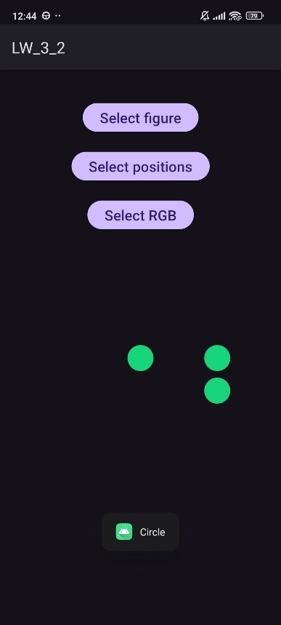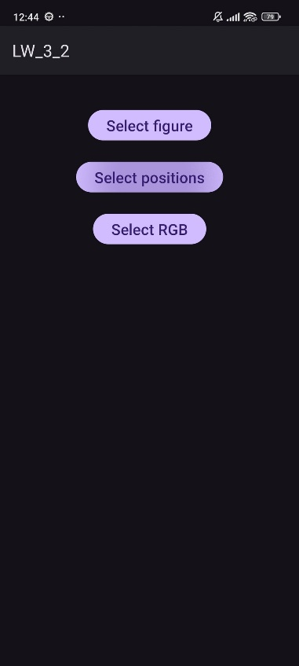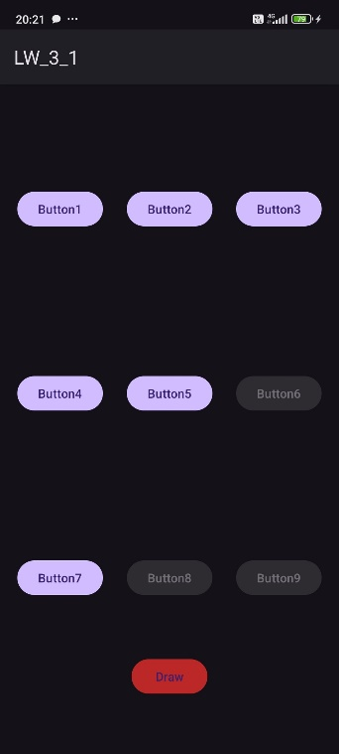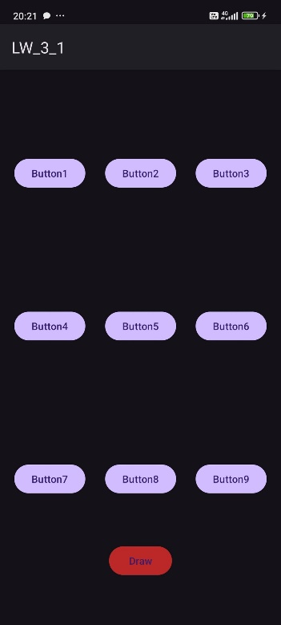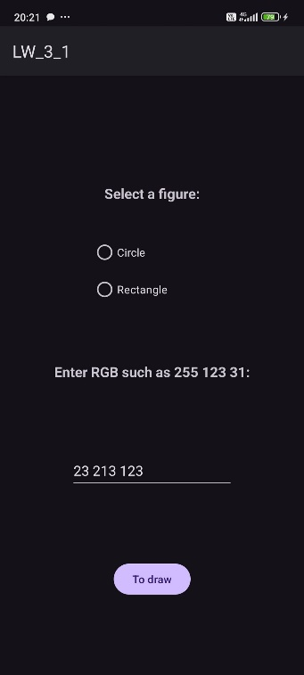**

**Вывод:** в ходе лабораторной работы были получены практические навыки по создания и взаимодействия нескольких Activity.